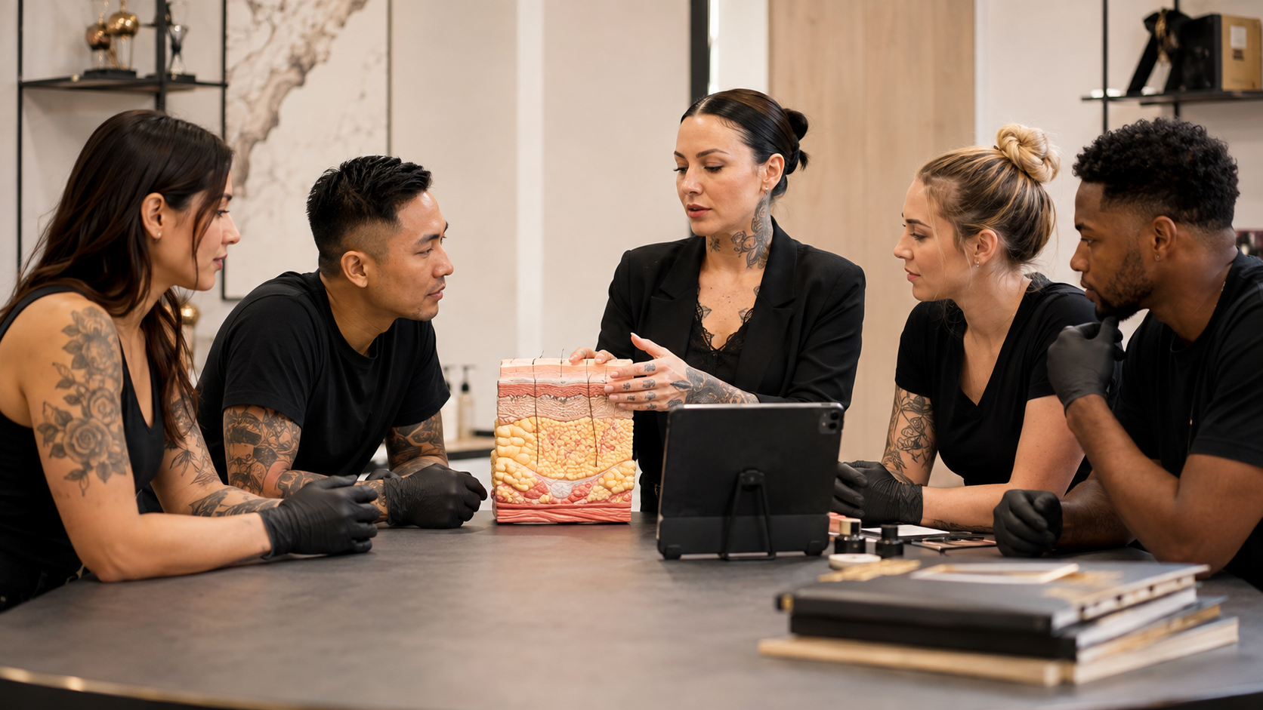

Skin Anatomy for Body Artists
  - Practical Workbook
BAQA SKILL DEVELOPMENT SHORT COURSE | USD 10 | ABOUT 90 MINUTES PLUS FOUR PRACTICAL ACTIVITIES
Learn how skin structure, variation, healing, ageing and scar tissue affect responsible body art decisions.

How to use this workbook
Complete each activity after the matching lesson. Use examples from procedures you are already trained and authorised to perform. Keep the workbook as evidence of continuing professional development and review it when products, studio systems or local requirements change.

Course boundary
This short course provides practical skin-anatomy education for body art professionals. It does not qualify a learner to perform a procedure, diagnose or treat a skin condition, select a medical treatment or work outside existing discipline training. Do not work on skin that appears unsuitable for an elective procedure. Refer concerns to an appropriate qualified health professional and follow local requirements.
Learner name
_______________________________________________________________________________________________
Studio and country or region
_______________________________________________________________________________________________

LESSON 1 | 20 MINUTES PLUS A 10-MINUTE ACTIVITY

The Skin Barrier and Its Main Layers
Understand the epidermis dermis and deeper tissue without turning anatomy into unsafe depth instructions.

Lesson check
- Name the epidermis dermis and subcutaneous tissue.
- Explain the skin's barrier role in plain language.
- Connect anatomy knowledge with safer preparation and referral decisions.

Practical activity
Draw a simple three-layer skin diagram in the workbook. Beside each layer, write its main protective or support function and one reason an artist must stay within discipline-specific training.
What I observed or decided
_______________________________________________________________________________________________
_______________________________________________________________________________________________
_______________________________________________________________________________________________
What I will change in my work
_______________________________________________________________________________________________
_______________________________________________________________________________________________
Evidence or local source checked
_______________________________________________________________________________________________

LESSON 2 | 15 MINUTES PLUS A 10-MINUTE ACTIVITY

Skin Varies by Person and Body Site
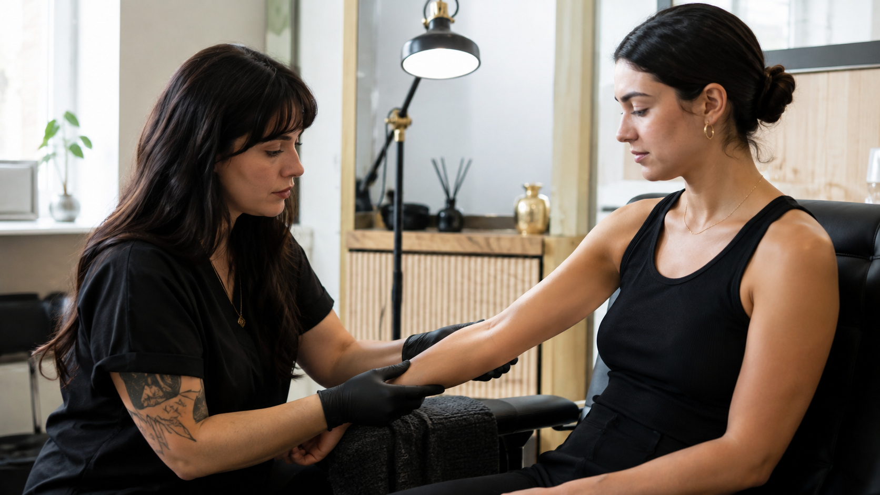
Assess the individual and procedure area instead of assuming all skin behaves the same way.

Lesson check
- Identify common sources of normal skin variation.
- Explain why age site exposure and history matter.
- Use a respectful pre-procedure skin observation record.

Practical activity
Build a body-site assessment checklist for your discipline. Include skin intactness, movement, friction, sun exposure, previous work, scarring, current treatment, positioning and reasons to postpone.
What I observed or decided
_______________________________________________________________________________________________
_______________________________________________________________________________________________
_______________________________________________________________________________________________
What I will change in my work
_______________________________________________________________________________________________
_______________________________________________________________________________________________
Evidence or local source checked
_______________________________________________________________________________________________

LESSON 3 | 20 MINUTES PLUS A 10-MINUTE ACTIVITY

Controlled Trauma and Healing
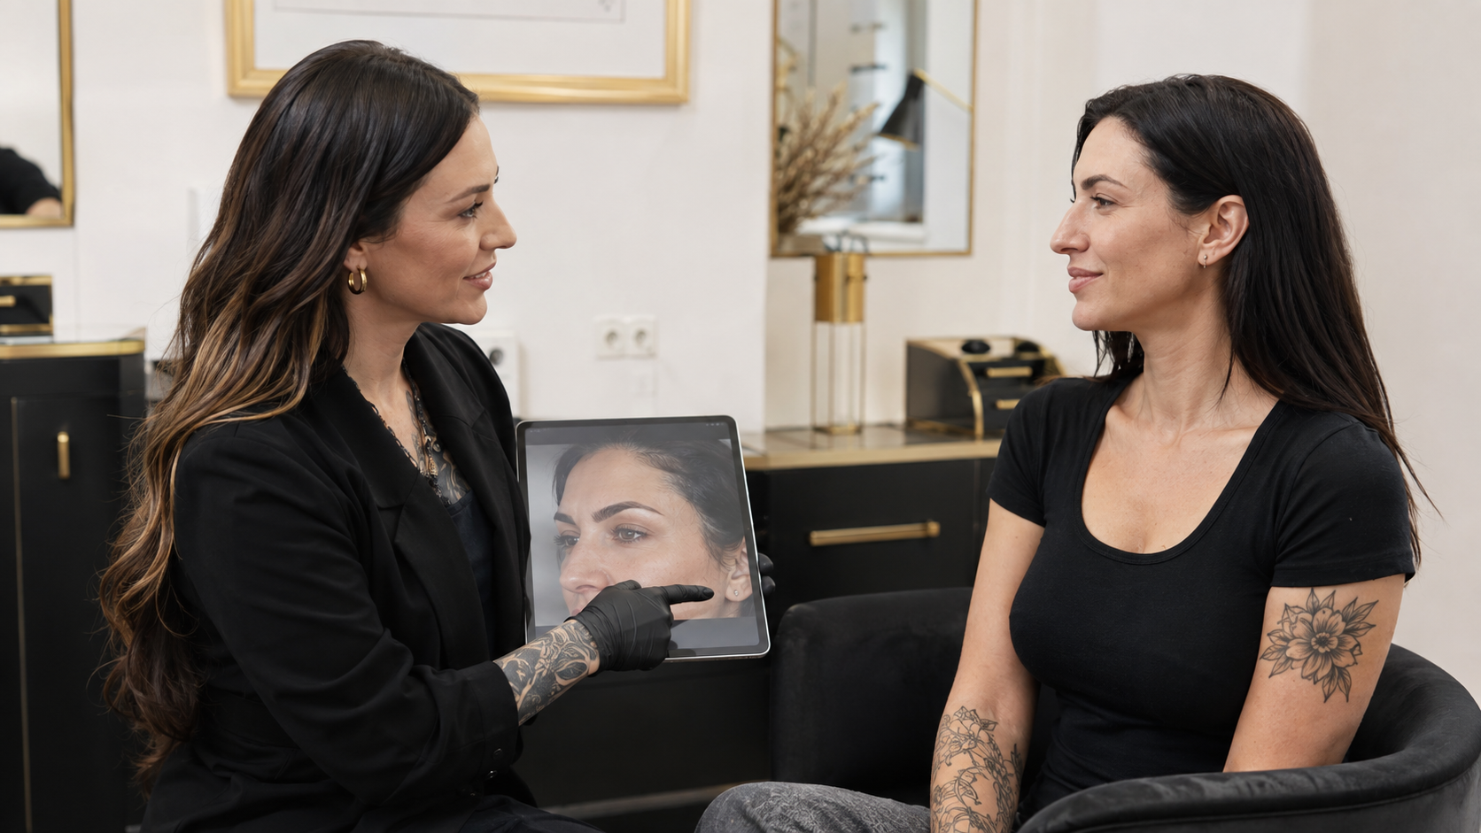
Understand the broad healing process and why fixed promises are unsafe.

Lesson check
- Describe the broad inflammatory repair and remodelling stages.
- Explain why healing time varies.
- Plan follow-up around observable healing rather than a fixed date alone.

Practical activity
Create a follow-up timeline that separates expected review points from guaranteed healing dates. Add the questions you will ask and the warning signs that trigger medical referral.
What I observed or decided
_______________________________________________________________________________________________
_______________________________________________________________________________________________
_______________________________________________________________________________________________
What I will change in my work
_______________________________________________________________________________________________
_______________________________________________________________________________________________
Evidence or local source checked
_______________________________________________________________________________________________

LESSON 4 | 20 MINUTES PLUS A 15-MINUTE ACTIVITY

Scar Tissue Ageing Skin and Referral
Recognise when changed skin needs specialist assessment or a more conservative plan.

Lesson check
- Describe common ways scar tissue may differ from surrounding skin.
- Adjust consultation expectations for ageing or previously treated skin.
- Recognise when not to proceed and how to refer without diagnosing.

Practical activity
Write three short referral scripts: one for skin that is still healing, one for an unexplained lesion and one for unstable scar tissue. Each script should describe the observation, the decision not to proceed and the next appropriate step without naming a diagnosis.
What I observed or decided
_______________________________________________________________________________________________
_______________________________________________________________________________________________
_______________________________________________________________________________________________
What I will change in my work
_______________________________________________________________________________________________
_______________________________________________________________________________________________
Evidence or local source checked
_______________________________________________________________________________________________

COURSE COMPLETION

Action Plan and Final Declaration
Choose three improvements that are specific enough to complete and check. These may involve a consultation prompt, record, product control, referral route, lighting setup, training need or studio procedure.
No | Improvement | Owner | Review date
1
2
3

Sources and local requirements
- NCBI Anatomy Skin Epidermis: https://www.ncbi.nlm.nih.gov/books/NBK470464/
- NCBI In Brief How Does Skin Work: https://www.ncbi.nlm.nih.gov/books/NBK279255/
- NHS Scars: https://www.nhs.uk/conditions/scars/
Confirm the current law, professional guidance, product instructions and referral contacts that apply where you work.

Final declaration
I completed the four activities and understand the course boundary. I will apply this knowledge only within my existing training, competence and local requirements.
Learner signature
_______________________________________________________________________________________________
Completion date
_______________________________________________________________________________________________

