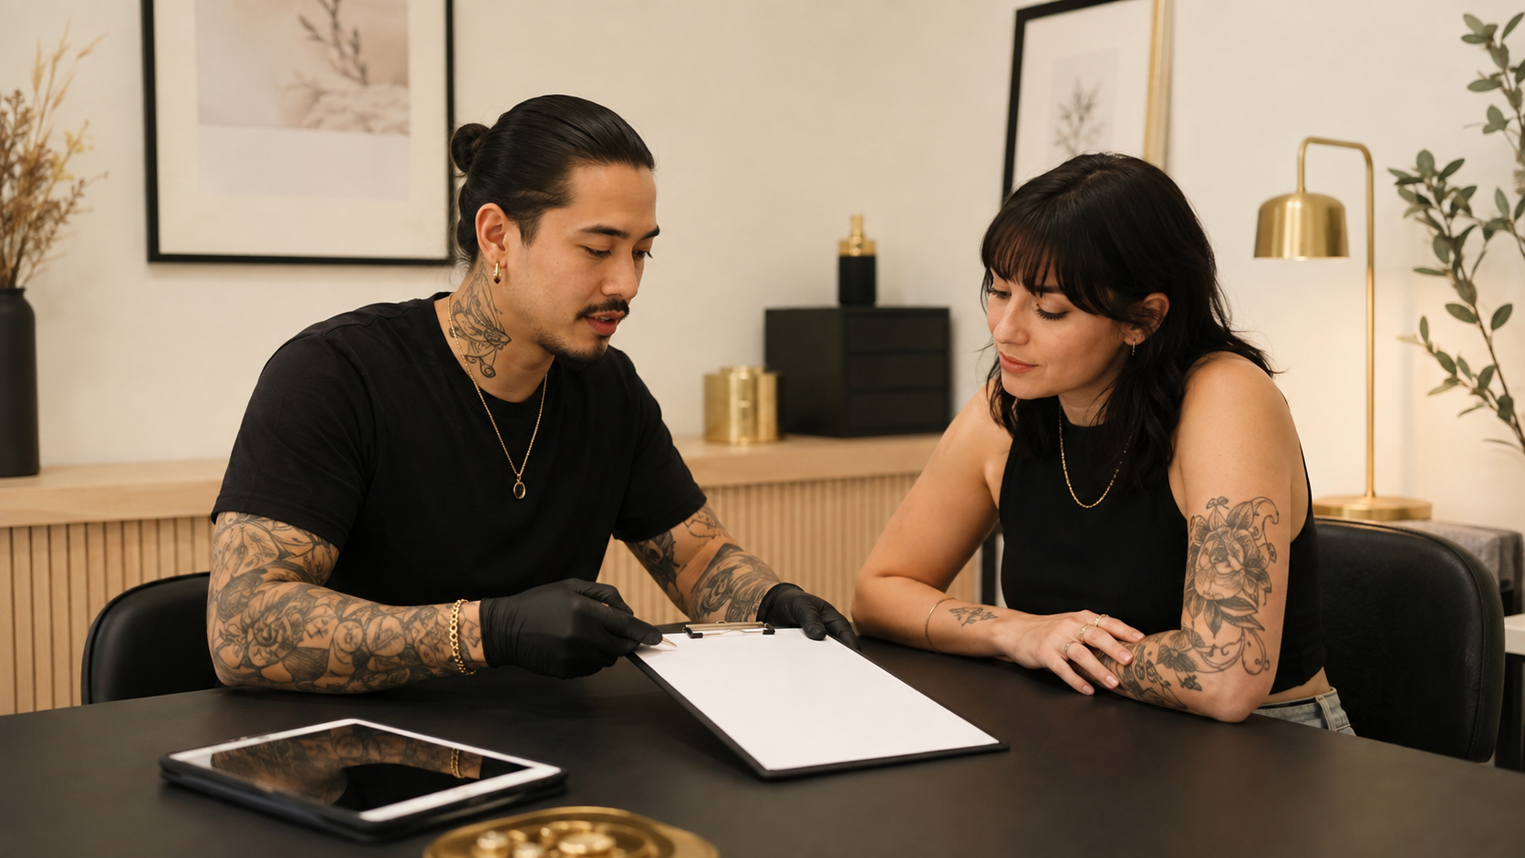

Client Consultation and Consent
  - Practical Workbook
BAQA SKILL DEVELOPMENT SHORT COURSE | USD 10 | ABOUT 90 MINUTES PLUS FOUR PRACTICAL ACTIVITIES
Run clear consultations manage expectations record informed choices and protect client privacy across body art disciplines.

How to use this workbook
Complete each activity after the matching lesson. Use examples from procedures you are already trained and authorised to perform. Keep the workbook as evidence of continuing professional development and review it when products, studio systems or local requirements change.

Course boundary
This short course provides general consultation consent documentation and privacy education. It is not legal advice and does not replace the law where the studio operates. Rules for minors decision-making capacity health information photography record retention and electronic communication vary. Use current local requirements suitable professional advice and discipline-specific training before relying on a form or process.
Learner name
_______________________________________________________________________________________________
Studio and country or region
_______________________________________________________________________________________________

LESSON 1 | 15 MINUTES PLUS A 10-MINUTE ACTIVITY

A Consultation Is a Conversation
Create a private unhurried discussion that helps the client make a real choice.

Lesson check
- Explain the purpose of informed consent in plain language.
- Check understanding voluntariness and the right to pause or refuse.
- Recognise when communication or decision-making needs more support.

Practical activity
Practise a three-minute explanation of one procedure you are already qualified to perform. Include purpose, main risks, healing, aftercare, alternatives and the right to stop. Ask a colleague to repeat the key points back.
What I observed or decided
_______________________________________________________________________________________________
_______________________________________________________________________________________________
_______________________________________________________________________________________________
What I will change in my work
_______________________________________________________________________________________________
_______________________________________________________________________________________________
Evidence or local source checked
_______________________________________________________________________________________________

LESSON 2 | 20 MINUTES PLUS A 10-MINUTE ACTIVITY

Health History and Suitability
Ask only relevant questions and know when to postpone decline or seek appropriate advice.

Lesson check
- Collect relevant history without diagnosing.
- Explain why sensitive questions are asked.
- Use a clear proceed postpone decline or refer decision.

Practical activity
Review your current consultation form. For each health question, write how the answer could change the decision. Remove questions with no clear purpose and add any missing procedure-specific prompts.
What I observed or decided
_______________________________________________________________________________________________
_______________________________________________________________________________________________
_______________________________________________________________________________________________
What I will change in my work
_______________________________________________________________________________________________
_______________________________________________________________________________________________
Evidence or local source checked
_______________________________________________________________________________________________

LESSON 3 | 20 MINUTES PLUS A 10-MINUTE ACTIVITY

Expectations Design and Aftercare
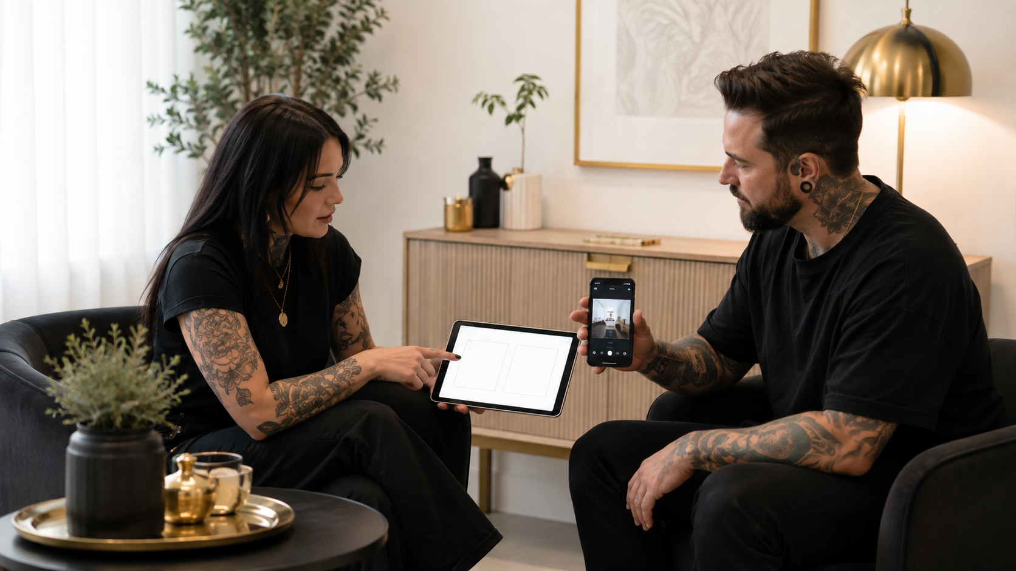
Agree the intended outcome and explain limits before taking payment or starting work.

Lesson check
- Turn an inspiration image into a realistic agreed plan.
- Explain uncertainty touch-up limits and aftercare responsibilities.
- Record design placement jewellery colour or treatment choices accurately.

Practical activity
Choose one common inspiration image and write a consultation response that separates the client's goal, adaptable features, limits, important risks, alternatives and the exact plan that would require confirmation.
What I observed or decided
_______________________________________________________________________________________________
_______________________________________________________________________________________________
_______________________________________________________________________________________________
What I will change in my work
_______________________________________________________________________________________________
_______________________________________________________________________________________________
Evidence or local source checked
_______________________________________________________________________________________________

LESSON 4 | 20 MINUTES PLUS A 15-MINUTE ACTIVITY

Records Photography and Professional Boundaries

Keep evidence secure obtain separate image permission and handle difficult consultations professionally.

Lesson check
- Create a complete traceable consultation and consent record.
- Separate procedure consent from photography and marketing permission.
- Protect privacy and end unsafe or abusive consultations appropriately.

Practical activity
Create a records map showing where consultation forms consent changes procedure records product details aftercare photographs messages and incident notes are stored who can access them and when they are reviewed or securely disposed of.
What I observed or decided
_______________________________________________________________________________________________
_______________________________________________________________________________________________
_______________________________________________________________________________________________
What I will change in my work
_______________________________________________________________________________________________
_______________________________________________________________________________________________
Evidence or local source checked
_______________________________________________________________________________________________

COURSE COMPLETION

Action Plan and Final Declaration
Choose three improvements that are specific enough to complete and check. These may involve a consultation prompt, record, product control, referral route, lighting setup, training need or studio procedure.
No | Improvement | Owner | Review date
1
2
3

Sources and local requirements
- WHO Patient Safety Rights Charter: https://www.who.int/publications/i/item/9789240093249
- WHO Global Patient Safety Action Plan: https://www.who.int/publications/i/item/9789240032705
- FDA Tattoos and Permanent Makeup Fact Sheet: https://www.fda.gov/cosmetics/cosmetic-products/tattoos-permanent-makeup-fact-sheet
Confirm the current law, professional guidance, product instructions and referral contacts that apply where you work.

Final declaration
I completed the four activities and understand the course boundary. I will apply this knowledge only within my existing training, competence and local requirements.
Learner signature
_______________________________________________________________________________________________
Completion date
_______________________________________________________________________________________________

