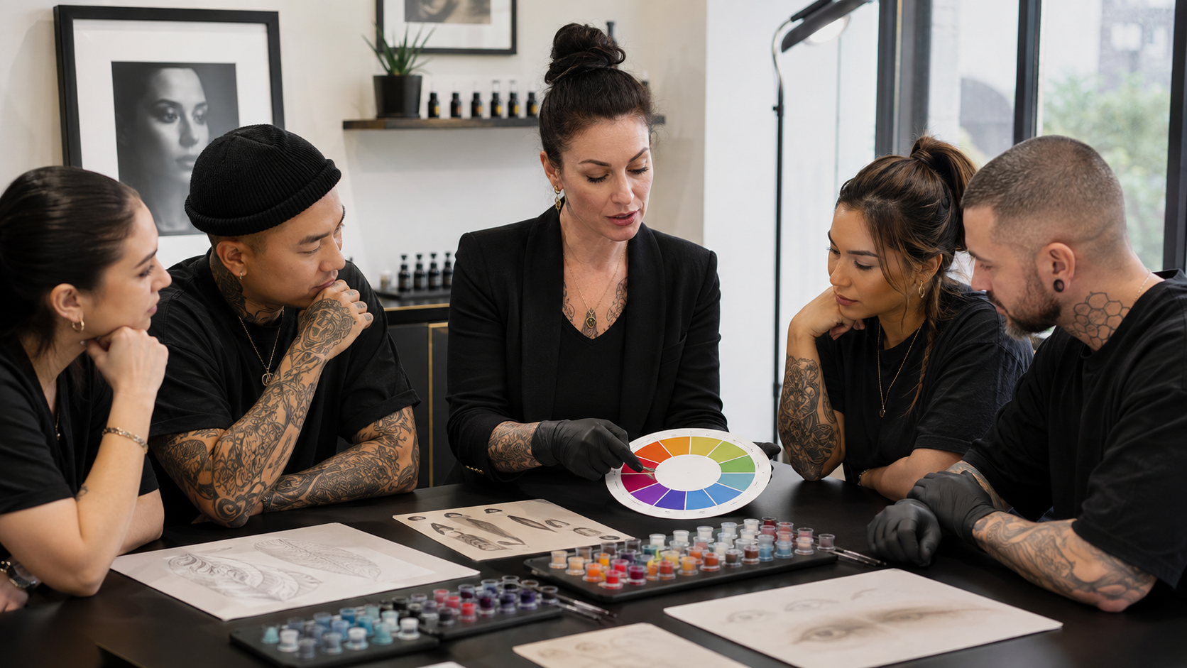

Body Art Color Theory
  - Practical Workbook
BAQA SKILL DEVELOPMENT SHORT COURSE | USD 10 | ABOUT 90 MINUTES PLUS FOUR PRACTICAL ACTIVITIES
Understand colour relationships, skin tone, pigment behaviour, healed colour and correction planning across tattooing, PMU and SMP.

How to use this workbook
Complete each activity after the matching lesson. Use examples from procedures you are already trained and authorised to perform. Keep the workbook as evidence of continuing professional development and review it when products, studio systems or local requirements change.

Course boundary
This short course explains colour-planning principles. It does not qualify a learner to perform tattooing, permanent makeup, microblading or scalp micropigmentation, approve a product, prescribe a pigment formula, diagnose a skin condition or guarantee a healed result. Use only lawful products intended for the procedure, follow the manufacturer's current instructions, work within your training and follow local requirements.
Learner name
_______________________________________________________________________________________________
Studio and country or region
_______________________________________________________________________________________________

LESSON 1 | 15 MINUTES PLUS A 10-MINUTE ACTIVITY

See and Describe Colour Clearly
Use hue, value and chroma to discuss colour accurately instead of relying on vague names.

Lesson check
- Explain hue, value and chroma in everyday language.
- Describe how lighting and surrounding colour change what you think you see.
- Create a repeatable colour-observation setup for consultations and healed-result reviews.

Practical activity
Choose three lawful pigment or ink samples from one manufacturer system. Under neutral light, describe each sample by hue, value and chroma. Repeat the exercise under a warmer light and record what appears to change.
What I observed or decided
_______________________________________________________________________________________________
_______________________________________________________________________________________________
_______________________________________________________________________________________________
What I will change in my work
_______________________________________________________________________________________________
_______________________________________________________________________________________________
Evidence or local source checked
_______________________________________________________________________________________________

LESSON 2 | 15 MINUTES PLUS A 10-MINUTE ACTIVITY

Skin Tone Undertone and Contrast
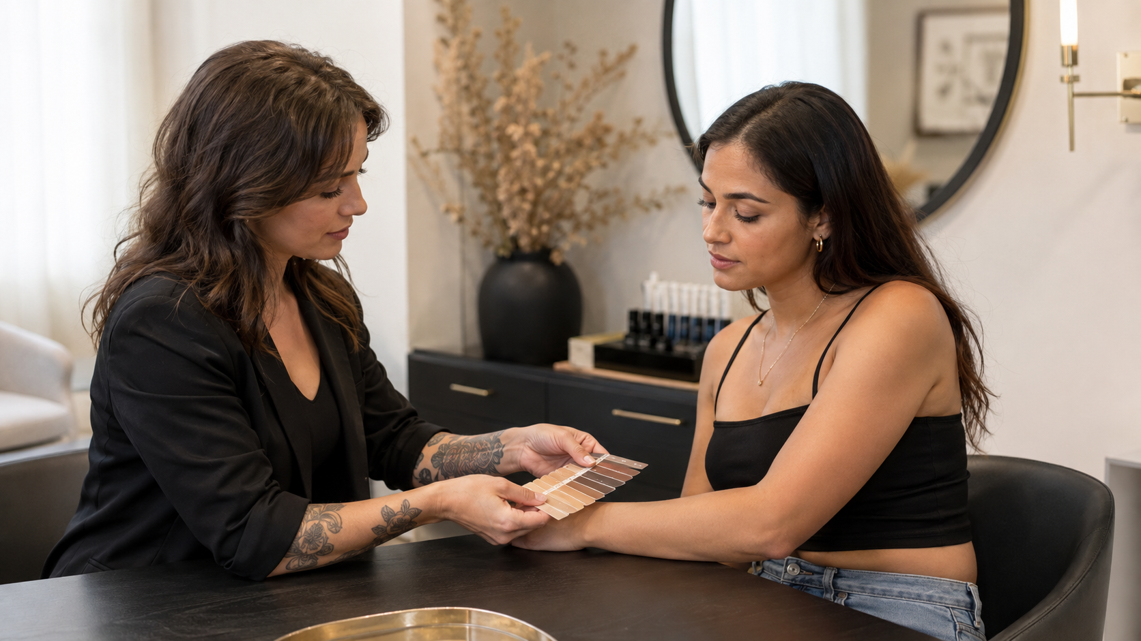
Separate visible skin depth, undertone and sun-response type when planning colour.

Lesson check
- Explain why skin is part of the final visible colour.
- Avoid treating the Fitzpatrick scale as a complete colour-matching system.
- Use respectful observation and examples across a wide range of skin tones.

Practical activity
Create a consultation note with separate fields for visible skin depth, observed undertone, contrast needed, relevant sun-response history and the limits of the observation. Test it with three anonymised practice examples.
What I observed or decided
_______________________________________________________________________________________________
_______________________________________________________________________________________________
_______________________________________________________________________________________________
What I will change in my work
_______________________________________________________________________________________________
_______________________________________________________________________________________________
Evidence or local source checked
_______________________________________________________________________________________________

LESSON 3 | 20 MINUTES PLUS A 10-MINUTE ACTIVITY

Pigment Behaviour and Safe Product Use
Connect product choice, application, healing and fading without inventing unsafe mixing rules.

Lesson check
- Explain why fresh and healed colour are not identical.
- Use product labels, lot records and manufacturer instructions when planning colour.
- Avoid unsafe cross-brand mixing and improvised dilution.

Practical activity
Audit five pigments or inks in your studio. Record intended use, manufacturer, lot, expiry, storage instructions, supported mixing information and where safety or recall information can be checked.
What I observed or decided
_______________________________________________________________________________________________
_______________________________________________________________________________________________
_______________________________________________________________________________________________
What I will change in my work
_______________________________________________________________________________________________
_______________________________________________________________________________________________
Evidence or local source checked
_______________________________________________________________________________________________

LESSON 4 | 20 MINUTES PLUS A 15-MINUTE ACTIVITY

Neutralisation and Correction Planning
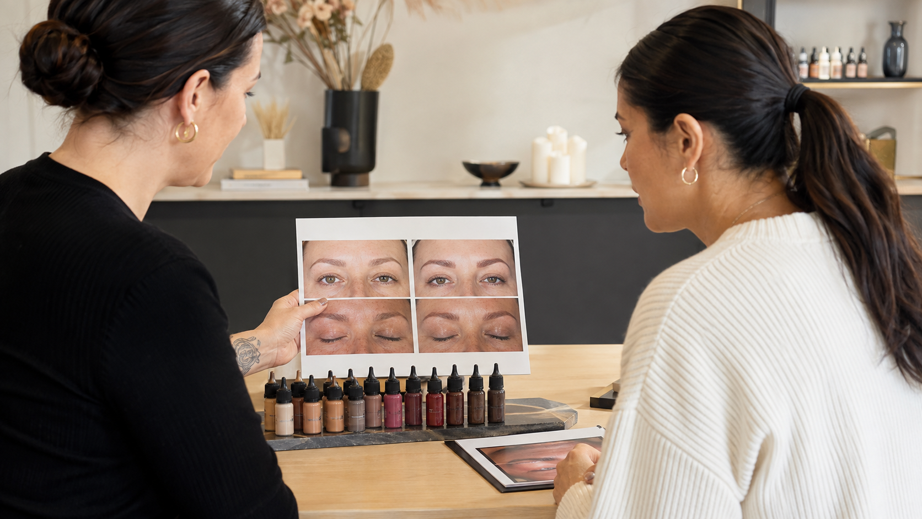
Use complementary colour relationships as a planning aid while respecting product and procedure limits.

Lesson check
- Use complementary colour relationships without treating them as automatic formulas.
- Assess the existing colour, skin, target and procedure history before correction.
- Recognise when removal, referral, healing time or no treatment is safer than adding colour.

Practical activity
Use the workbook to plan two fictional corrections. Record the healed starting colour, known product history, uncertainty, intended outcome, supported product system, alternatives, reasons to postpone and the point at which you would refer.
What I observed or decided
_______________________________________________________________________________________________
_______________________________________________________________________________________________
_______________________________________________________________________________________________
What I will change in my work
_______________________________________________________________________________________________
_______________________________________________________________________________________________
Evidence or local source checked
_______________________________________________________________________________________________

COURSE COMPLETION

Action Plan and Final Declaration
Choose three improvements that are specific enough to complete and check. These may involve a consultation prompt, record, product control, referral route, lighting setup, training need or studio procedure.
No | Improvement | Owner | Review date
1
2
3

Sources and local requirements
- FDA Tattoos and Permanent Makeup Fact Sheet: https://www.fda.gov/cosmetics/cosmetic-products/tattoos-permanent-makeup-fact-sheet
- European Chemicals Agency Tattoo Inks and Permanent Makeup: https://echa.europa.eu/hot-topics/tattoo-inks
- NCBI Skin Anatomy and the Epidermis: https://www.ncbi.nlm.nih.gov/books/NBK470464/
Confirm the current law, professional guidance, product instructions and referral contacts that apply where you work.

Final declaration
I completed the four activities and understand the course boundary. I will apply this knowledge only within my existing training, competence and local requirements.
Learner signature
_______________________________________________________________________________________________
Completion date
_______________________________________________________________________________________________

