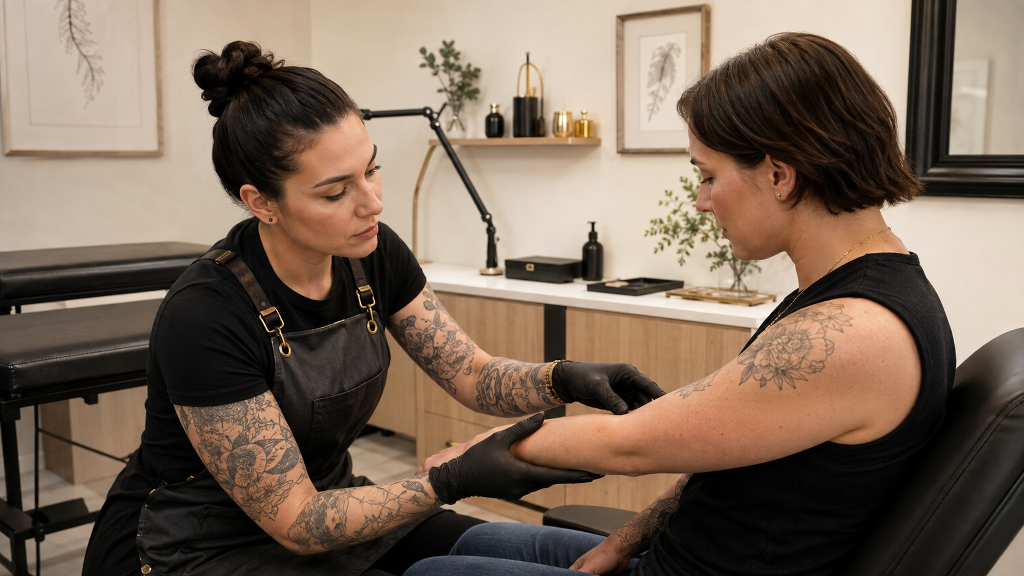

Body Art Complications
  - Practical Workbook
BAQA SKILL DEVELOPMENT SHORT COURSE | USD 10 | ABOUT 90 MINUTES PLUS FOUR PRACTICAL ACTIVITIES
Recognise concerning changes respond within scope document clearly and refer clients appropriately after body art procedures.

How to use this workbook
Complete each activity after the matching lesson. Use examples from procedures you are already trained and authorised to perform. Keep the workbook as evidence of continuing professional development and review it when products, studio systems or local requirements change.

Course boundary
This short course teaches recognition response documentation and referral principles. It does not qualify a learner to diagnose or treat infection allergy anaphylaxis scarring or any other medical condition, and it does not replace emergency training or discipline-specific practical education. Stop elective work when there is a concern, arrange urgent help for emergency warning signs, refer medical questions to a qualified health professional and follow local reporting requirements.
Learner name
_______________________________________________________________________________________________
Studio and country or region
_______________________________________________________________________________________________

LESSON 1 | 20 MINUTES PLUS A 10-MINUTE ACTIVITY

Normal Healing or a Concern
Compare the expected healing pattern with changes that are worsening unusual or outside your scope.

Lesson check
- Separate expected healing information from medical diagnosis.
- Ask useful questions about timing trend and symptoms.
- Recognise when elective work or rework must stop.

Practical activity
Create a follow-up question set that records timing trend symptoms photographs advice and referral. Test it against one expected-healing scenario and one worsening scenario.
What I observed or decided
_______________________________________________________________________________________________
_______________________________________________________________________________________________
_______________________________________________________________________________________________
What I will change in my work
_______________________________________________________________________________________________
_______________________________________________________________________________________________
Evidence or local source checked
_______________________________________________________________________________________________

LESSON 2 | 20 MINUTES PLUS A 10-MINUTE ACTIVITY

Infection Irritation and Allergy Warning Signs

Recognise patterns that need prompt or emergency medical assessment without diagnosing them.

Lesson check
- Identify common warning signs that require medical assessment.
- Distinguish a local concern from emergency symptoms.
- Give clear referral advice without prescribing treatment.

Practical activity
Write a two-level referral card for your studio: prompt medical assessment and emergency assistance. Use observable warning signs and insert the correct local services.
What I observed or decided
_______________________________________________________________________________________________
_______________________________________________________________________________________________
_______________________________________________________________________________________________
What I will change in my work
_______________________________________________________________________________________________
_______________________________________________________________________________________________
Evidence or local source checked
_______________________________________________________________________________________________

LESSON 3 | 20 MINUTES PLUS A 10-MINUTE ACTIVITY

Migration Rejection Scarring and Poor Results
Recognise common technical or healing problems and avoid premature corrective work.

Lesson check
- Describe blowout migration rejection scarring and poor retention without overdiagnosis.
- Separate immediate safety from later aesthetic correction.
- Recognise when a specialist referral or no further work is appropriate.

Practical activity
Use the workbook to analyse three fictional cases: blurred pigment, migrating jewellery and poor retention. Separate observable facts, possible contributing factors, immediate safety needs, referral and later aesthetic options.
What I observed or decided
_______________________________________________________________________________________________
_______________________________________________________________________________________________
_______________________________________________________________________________________________
What I will change in my work
_______________________________________________________________________________________________
_______________________________________________________________________________________________
Evidence or local source checked
_______________________________________________________________________________________________

LESSON 4 | 20 MINUTES PLUS A 15-MINUTE ACTIVITY

Respond Document Refer and Review

Use a consistent studio pathway when a client reports a complication.

Lesson check
- Use a clear response pathway from first contact to closure.
- Preserve privacy evidence and product traceability.
- Review incidents to improve systems without hiding or blaming.

Practical activity
Run a tabletop exercise from a fictional client message reporting worsening redness and fever. Practise triage wording, referral, record preservation, internal notification and the later incident review.
What I observed or decided
_______________________________________________________________________________________________
_______________________________________________________________________________________________
_______________________________________________________________________________________________
What I will change in my work
_______________________________________________________________________________________________
_______________________________________________________________________________________________
Evidence or local source checked
_______________________________________________________________________________________________

COURSE COMPLETION

Action Plan and Final Declaration
Choose three improvements that are specific enough to complete and check. These may involve a consultation prompt, record, product control, referral route, lighting setup, training need or studio procedure.
No | Improvement | Owner | Review date
1
2
3

Sources and local requirements
- FDA Tattoos and Permanent Makeup Fact Sheet: https://www.fda.gov/cosmetics/cosmetic-products/tattoos-permanent-makeup-fact-sheet
- CDC Occupational Exposure to Blood: https://www.cdc.gov/dental-infection-control/hcp/dental-ipc-faqs/occupational-exposure.html
- NHS Anaphylaxis: https://www.nhs.uk/conditions/anaphylaxis/
- NHS Cellulitis: https://www.nhs.uk/conditions/cellulitis/
Confirm the current law, professional guidance, product instructions and referral contacts that apply where you work.

Final declaration
I completed the four activities and understand the course boundary. I will apply this knowledge only within my existing training, competence and local requirements.
Learner signature
_______________________________________________________________________________________________
Completion date
_______________________________________________________________________________________________

